Taylan Unal

Professor Heberling

IST 210

9/13/18

Magnet Supply Company (Lab 1)

**YOUR LAB ASSIGNMENT**

Here is the lab assignment:

1. Create a data dictionary for Magnet Supply Company Order System using the data dictionary example in the textbook as the format. [EXCEL]

2. Create a relational diagram for Magnet Supply Company Order System. [VISIO]

3. Execute SQL select commands (see “Getting Started” lab) and answer the following questions: (answer the question but also provide SQL and result) [WORD]

1. **How many different job codes are available?:**
   * In dbo.MSC_job, there are currently 9 different job codes present.

***SELECT TOP (1000) [job_code],[job_description]***

***FROM [IST210-ONLINE].[dbo].[MSC_job]***

***----------- ------------------------------***

***1 CEO***

***2 Vice President***

***3 Accountant***

***4 Clerk***

***5 Information Technology***

***6 Warehouse***

***7 Salesman***

***8 Laborer***

***9 Maintenance***

***(9 row(s) affected)***

1. **What is the job code for Louise Daniel?:**
   * Louise Daniel is listed under job code 9, or Maintenance. (Check Job Codes and Employees tables. Write SQL query for both).

***select job_code from dbo.MSC_Employee where empl_first_name='Louise'***

***AND empl_last_name='Daniel';***

***job_code***

***-----------***

***9***

***(1 row(s) affected)***

1. **What is/are the name(s) of the vendor(s) location in MI?:**
   * For this database, the only vendor located in Michigan is Industry Magnet Specialists located in Franklin, Michigan.

*select * from dbo.MSC_Vendor where vend_state='MI';*

***vend_number vend_name vend_street vend_city vend_state vend_zip***

***----------- ----------------------------------- --------------------------------------------------***

***3004 Industry Magnet Specialists 56 2nd Avenue Franklin MI 48025***

***(1 row(s) affected)***

1. **What is the order quantity in stock for product 4006?**
   * **For product 4006, there are currently 248 units in stock.**

***select * from dbo.MSC_Product_detail where prod_number=4006;***

***a***

***prod_number vend_number qty_in_stock***

***----------- ----------- ---------------------------------------***

***4006 3005 248***

***(1 row(s) affected)***

1. **What is the zip code for customer 1004?**
   * The zip for customer number 1004 is 34705 located in Astatula, Florida.

***select * from dbo.MSC_Customer where cust_number=1004;***

***cust_number cust_name cust_street cust_city cust_state cust_zip salesman_number***

***----------- -------------------------------------------------- -------------------------------------------------- ---***

***1004 Valentis 481 S Key Street Astatula FL 34705 214***

***(1 row(s) affected)***

1. **What is the sale price for product 4007?**
   * For product 4007 (Pentagon 2? x .25"), the sale price is $0.90 per unit.

***select * from dbo.MSC_Product_master where prod_number=4007;***

***prod_number prod_description sale_price commission_percent***

***------------------------------------------------------------------------------------------------------------------***

***4007 Pentagon 2? x .25" 0.90 0.0100***

***(1 row(s) affected)***

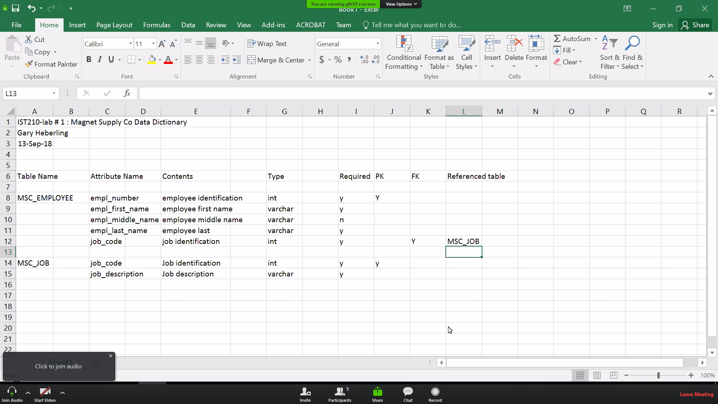

**(Inclass Example)**

Identify vendor, product, company info, customers, employees,

Needs rows affected, sql statement, and the results data.

In visio use Crows Foot template.